The Secretary,
Board of Technical Education,
Jammu and Kashmir.

No: KGP/Estt/2026/558 Dated: 29-06-2026

Subject: Submission of Seat Availability in 3rd Semester for All Branches.

Sir,
In response to your letter No. BOTE/Eval/26/1861, dated 29/06/2026, Kindly find below the details of vacant seats in the 3rd semester across all branches at our institution:

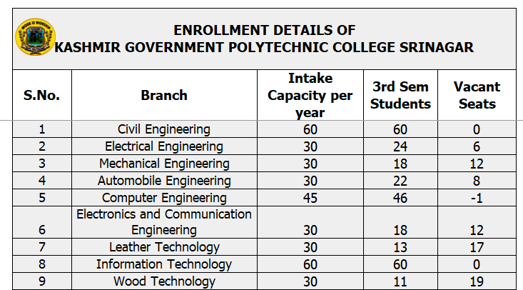


Yours Faithfully

Principal
Kashmir Government Polytechnic College
Srinagar

